**Radiologist-Level Computer-aided Detection to detect 14 common thoracic diseases**

by

Đạt Quang Trần

A thesis submitted to the Biomedical Engineering Department in partial fulfillment of the requirements for the degree of Engineer

Ho Chi Minh city, Vietnam

Feb-2019

**Radiologist-Level Computer-aided Detection to detect 14 common thoracic diseases**

APPROVED BY: ________________________________ ,   
Chair   
Võ Văn Tới

________________________________   
Ngô Thanh Hoàn

________________________________   
Phạm Thị Thu Hiền

________________________________   
Nguyễn Lê Thanh An

________________________________   
Lê Thị Anh Thơ

THESIS COMMITTEE   
(Whichever applies)

ACKNOWLEDGMENTS

Firstly, I would like to express my sincere gratitude to my advisor Ph.D. Phạm Thị Thu Hiền for her continuous support of my study and related research, for her patience, motivation, and immense knowledge. Her guidance helped me in all the time of research and writing of this thesis. I could not have imagined having a better advisor and mentor for my undergraduate study.

My sincere thanks also go to Tuấn Huệ Thi and his team in EyeQ, who provided me an opportunity to join their team and gave access to the laboratory and research facilities. Without their precious support, it would not be possible to conduct this research.

Last but not the least, I would like to thank my family for supporting me spiritually throughout this thesis.

# TABLE OF CONTENTS

TABLE OF CONTENTS iv

LIST OF TABLES vi

LIST OF FIGURES vii

Abstract 1

Chapter 1: Introduction 2

1. Problem statement 2

2. Organization of Thesis 3

Chapter 2: Literature Review 4

Chapter 3: Methodology 6

1. Overall architecture 6

2. Dataset 7

3. Thorax Classification 11

3.1: ResNet 11

3.2: DenseNet 15

4. Lung Segmentation 18

5. Loss Function 20

5.1: Lung Segmentation: 20

5.2: Thorax classification: 20

6. Learning rate finder 21

7. Training setting 22

7.1: Lung Segmentation: 22

7.2: Thorax Classification: 22

Chapter 4: Result 24

1. Hyperparameter tuning 24

1.1: Different learning rate 24

1.2: Different batch size 24

1.3: Training longer 25

2. Lung Segmentation 27

3. Thorax Classification 30

4. Class Activation Map (CAM) 35

5. Compare to related works in the literature 37

Chapter 5: Conclusion 38

Reference 40

# LIST OF TABLES

Table 3.1: List of 14 disease listed in ChestX-ray 14 and there description 8

Table 3.2: ResNet-50 architecture. 7×7, 64, s=2, p=3 denotes this layer has 64 filters with size 7×7, stride = 2 and padding = 3. 3@224×224 means width and height is 224, 3 channels. The number 50 denotes the total number of convolutional filter and fully connected filter. 13

Table 3.3: Densenet-121 Architecture. 7×7, 64, s=2,p=3 denotes this layer has 64 filters with size 7×7, stride = 2 and padding = 3. The number 121 denotes total number of convolutional filter and fully connected filter. 16

Table 4.1: Dice and IoU scores on segmentation task on JSRT on MC dataset 27

Table 4.2: IoU report in literature on JSRT dataset. 28

Table 4.3: Confusion matrix for each individual disease. 31

Table 4.4: Examples of output of the module. We present the top-10 disease with their corresponding probability. The ground truth labels are highlighted in blue. PT represents Pleural Thickening. 34

Table 4.5: Evaluation of different model on ChestX-ray 14 dataset, the performance is reported using the AUC score. Each pathology is denoted with its ﬁrst four characteristics, e.g., Atelectasis with Atel. Pneumonia and Pneumothorax are denoted as Pneu1 and Pneu2, respectively. PT represents Pleural Thickening. For each column, the best and second-best results are highlighted in red and blue, respectively. The results of our experiments are shown in **bold**. 37

# LIST OF FIGURES

Figure 3.1: The overall framework of Segmentation Guided Thorax Classification (SGTC) for lung disease classification. The framework also provides a means to visualize the result as Class Activation Map (CAM). 6

Figure 3.2: Example of different disease in ChestX-ray 14 dataset. 9

Figure 3.3: The circular diagram shows the proportions of images with multi-labels in each of 14 pathology classes and the labels’ co-occurrence statistics in ChestX-ray 14 dataset. 10

Figure 3.4: **Residual Layer**: the convolution on shortcut path perform linear mapping to ensure dimension matching. 14

Figure 3.5: **Down Layer**: Instead of using pooling layer to down sample, ResNet family use convolution filter with **stride = 2** to do the jobs. This layer is identical to the ResLayer except for the stride of the middle convolution. 14

Figure 3.6: Visualize the **ResNet-50** architecture. 14

Figure 3.7: **Dense Layer** concatenates the result with the input. 17

Figure 3.8: **Transition Block**: 1×1 convolution follow by 2×2 pooling layer to decrease the spatial dimension of the feature maps. 17

Figure 3.9: **Dense Block**: Each Dense Layer learns the mapping for the input and concatenates with the input. So that every proceeding layer has direct access to all the output of all preceding layer. Dense Block with n Dense Layers will transform the input from c channels to **c+32n** channels. 17

Figure 3.10: Visualizing **Densenet-121** architecture. 17

Figure 3.11: **Up Layer:** This layer will restore the resolution of the input image with the feature from decoding path. 18

Figure 3.12: Unet with ResNet-50 as the backbone to do lung segmentation task. The down-sampling path is identical to the ResNet-50 that will encode the information. The up-sampling path will learn to decode the features map to reconstruct the input resolution with skip. 19

Figure 3.13: **Left**: Learning rate finder for lung segmentation, here we choose a learning rate of 1e-2. **Right**: Learning rate finder for ChestX-ray 14 dataset, here we choose a learning rate of 1e-3. 22

Figure 4.1: **Left**: Loss for different learning rates, **Right:** AUC for different learning rates. Different experiments were color-coded, the solid line shows the training result, the dashed line shows the validation result. Learning rate is denoted as lr. 25

Figure 4.2: **Left**: Loss for different batch sizes, **Right:** AUC for different batch sizes. Different experiments were color-coded, the solid line shows the training result, the dashed line shows the validation result. 26

Figure 4.3: **Left**: Loss for different epochs, **Right:** AUC for different epochs. Different experiments were color-coded, the solid line shows the training result, the dashed line shows the validation result. 26

Figure 4.4: Lung Segmentation result on **Top**: JSRT dataset, **Bottom**: MC dataset. The green contour indicates the ground truth and the red mask indicates the predicted mask. Ω denotes the IoU value. 28

Figure 4.5: Post processing to remove unwanted object and cut the lung region for classification. 29

Figure 4.6: Lung segmentation result in Chest X-ray 14 dataset on different lung size. The red mask indicates the predicted lung region, the bounding box is generated from the largest connected component in the binary mask. From the detected bounding box. We calculate the lung ratio (r) as the fraction of lung width over lung height. **Top:** r < 0.8, **Middle:** r ∈[0.8, 1.5], **Bottom:** r > 1.5. 29

Figure 4.7: Failed case on ChestX-ray 14. 30

Figure 4.8: Compare ROC for 14 different disease for ResNet-50 and DenseNet-121. 32

Figure 4.9: Compare ROC for 14 different disease for one stage on two stage model. 33

Figure 4.10: CAM for the top-1 disease. The 1st and 3rd row is the original image. The 2nd and 4th row show the CAM result for the top-1 disease. 36

# 

# Abstract

Lung diseases are the leading cause of death in developing countries. Chest X-ray (CXR) is the most common medical screening and the most effective way to diagnose a wide range of lung-related diseases. However, an effective interpretation of CXR requires experienced radiologists, which is especially lacking in a developing country like Vietnam. An effective CXR Computer-aided Detection (CAD) that can heftily assist radiologists in detecting Lung Disease can bring tremendous benefit to public healthcare. ChestX-ray14 is currently the largest public dataset on CXR that provide labels for 14 different lung diseases (i.e. Atelectasis, Cardiomegaly, Effusion, Infiltration, Mass, Nodule, Pneumonia, Pneumothorax, Consolidation, Edema, Emphysema, Fibrosis, Pleural Thickening, and Hernia). This enormous dataset has opened an opportunity to developed better radiology CAD system. In this study, we proposed the method called Segmentation Guided Thorax Classification that combines of two stages. The first stage use lung segmentation to get only the relevant area of the lung and remove unnecessary area. The second stage will leverage the deep learning model to classify the image. This method has yelled the average AUC (Area Under ROC Curve) of 0.843 on 14 different lung diseases. Our result is comparable to other approaches in the literature. We also produced a localization heatmap on the CXR that can greatly assist the doctor to make a better decision. Our method can provide radiologists with a means to make decisions faster and more accurate, hence lift a heavy load on the current medical system and provide better health care for patients.

**Keywords:** Chest X-ray (CXR), Deep Learning (DL), Receiver Operating Characteristic (ROC), Area Under Curve (AUC), Class Activation Map (CAM), Computer-aided Detection (CAD), Convolutional Neural Network (CNN), Japanese Society of Radiological Technology (JSRT), Montgomery County (MC).

# Introduction

## Problem statement

Lung diseases are among the most common medical condition in the world lung, which about 235 million people suffer from asthma, 200 million people have Chronic Obstructive Pulmonary Disease (COPD) [1]. In Vietnam alone, lung cancer and COPD is among the top 5 leading cause of death in 2017 [2]. The Chest X-ray (CXR) is the most frequently requested radiologic examination. due to its cheap, fast, reliable and can be used to diagnose many lungs and heart failure. Currently, CXR is the best available screening diagnosis for many diseases include Pneumonia and Cardiomegaly. However, an efficient interpretation of CXR requires radiologist years of experience and a tremendous amount of time. In addition, radiologist’s performance is usually evaluated in term of quantity [3] rather than the quality of their reports. This can lead to misinterpretation, low-quality report, unnecessary sub-sequence procedure and have a direct negative impact on patient health and medical infrastructure. An effective automatic CXR interpreter could provide a huge impact to improve radiologist workflow, patient prioritization and support decision making.

In the other hand, this humongous amount of data can be used to develop better CAD system that can assist radiologists in filtering obvious normal image and let radiologist focus on the hard case that can save doctor time and avoid misdiagnosis. In recent year, the advance in Computer Vision (CV) has been driven mainly by Deep Learning (DL). DL is the method that can learn the representation from a large amount of data that have out-performed human rival in many CV tasks. In 2017, [4] had published ChestX-14, the largest publicly available CXR with 112,000 images with label on 14 different lung diseases (i.e. Atelectasis, Cardiomegaly, Effusion, Infiltration, Mass, Nodule, Pneumonia, Pneumothorax, Consolidation, Edema, Emphysema, Fibrosis, Pleural Thickening, and Hernia) with 112,000 images. This huge dataset had provided opportunities to develop better CAD system that can greatly help the radiologist.

Since the release of the dataset, [5] have reported the result that reaches the performance of experienced radiologists in constrained evaluation setting. Other notable results have been reported were [6], [7], and [8]. Base on the result of [7], we can see that not every region of the CXR is useful as the input, but only the lung and heart areas contain the most important features for the diagnosis. In this study, we introduced a two-stage Segmentation Guided Thorax Classification to classify CXR images. In the first stage, the model segmented the lung region in CXR and cut all the region that contains the lung. In the second stage, the model took the segmented lung and classified thorax disease. The proposed method had achieved average Area Under Curve (AUC) score of 0.84. Furthermore, we also provided localization heatmap to address clinical interpretability and assist radiology greatly.

## Organization of Thesis

The remaining of this thesis is divided into the following sections:

Chapter 2: Literature Review will show techniques researcher has been used in literature.  
Chapter 3: Methodology will show the DL framework we developed to tackle the problem.  
Chapter 4: Result will show our result and the experiment conducted.  
Chapter 5: Conclusion will show a summary of the study and some further development ideas.

# Literature Review

Convolutional Neural Network (CNN) is some of the most influential ideas in computer vision and is currently the de facto method for many imaging tasks. Traditionally, researchers often use hand design convolutional filter to perform various image processing tasks such as image sharpening, edge detection, and morphological filtering. In CNN, a convolutional filter is learned through an algorithm call backpropagation that slowly updates the value of the filter to minimize the predefine loss. Although each filter can only perform a limited task, when we stack them on together, they can be used to perform a very complex task. Deep Learning (DL) is the method of stacking layers of convolutional filters in order to learn the hierarchical layer of features.

Prior to DL, researchers had many different approaches to implement Computer-aided Detection (CAD) to assist radiologist. [9] used Haar wavelet transform to extract lung feature image and weighted nearest neighbors base on Euclidean distance to measure the similarity between images. [10] use Fuzzy C-means clustering for feature extraction and classification.

Since 2012, after the wining of AlexNet [11] on ImageNet [12] challenge, the advantage of DL have driven many outstanding result on many natural imaging tasks include object classification [13], [14]; object detection [15], [16] and semantics segmentation [17], [18]. In 2015, medical researchers had started to applied DL techniques to various biomedical tasks. In biomedical imaging, [19] developed a model to detect diabetic retinopathy and diabetic macular edema from retinal fundus imaging; [20] developed a model to detect different pathology of skin cancer from dermatology image; [21] developed a model to detect cancer metastases from gigapixel pathology imaging. In biomedical signaling, [22] developed a model to classify ECG into 14 rhythm classes.

Since the introduction of [4] ChextX-ray14 dataset, many researchers have developed DL algorithm that leverage this large amount of data. [5] used a one-stage model that put a global image through a single DL model that perform both the classification and detection of thorax disease. In [23], ensemble learning was used to increase the performance at the cost of increasing both training and inference time. [6] used a two-stage model combine of an encoder and a classifier, the encoder used DenseNet-121 [14] to extract features from the CXR image, the second stage used Long Short Term Memory [24] to model the dependencies among disease. [7] combined Global, Local and Fusion branches to form a three-stage model and achieved SOTA result. In Global Branch, they used the same model as [5] to generate attention heatmap from extracted features and use that heatmap to cropped the highly activated region as the input to train the Local Branch. The Fusion Branch then fused the result of 2 previous models to output the final prediction. Base on the result of [7], it is clear that not all region in the CXR is relevant to the final prediction. This led us to the idea of using lung segmentation to cut region of interest from the CXR.

Semantic Segmentation is understanding image at pixel-level, i.e. to assign a label to every pixel in the images. This is a much challenging problem than image classification. In lung segmentation specifically, there are several approaches. In [25] the author used a shape similarity to query a set of similar lungs that had been annotated and SIFT [26] features to perform segmentation. This approach was memory and computational inefficient since the system had to store all the previous segmented lung and perform feature matching on every similar image. The method is also error-prone to an extreme case. In 2015, [27] introduced a method base on DL for fast biomedical imaging segmentation call U-net consists of an encoder and a decoder network. The resulting model is fast and can be applied to other segmentation tasks in biomedical field. In [28], the author used an U-net base model to perform lung segmentation and archive SOTA on Japanese Society of Radiological Technology (JSRT) [29] dataset.

# Methodology

## Overall architecture

Figure 3.1 describes the overall framework of our proposed method, Segmentation Guided Thorax Classification (SGTC). The SGTC consists of two stages. In the segmentation stage, we performed lung segmentation task on Chest X-ray (CXR) image using Unet model. We then cropped the lung region, resized and input to a ChexNet model to extract representation features. The features extracted then used to classifier 14 different diseases. We also applied the features back to the input image to provide Class Activation Map (CAM) [30] result. An advantage of this approach is the classifier only exposes the lung region of the image, eliminate unnecessary noise from the background, which in turn prompt a better result.

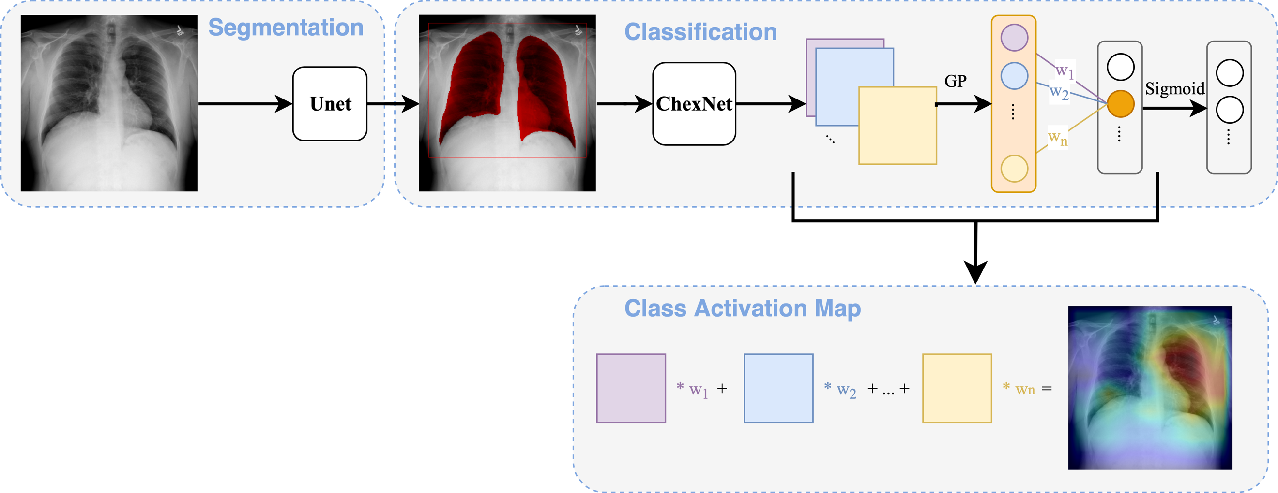

Figure 3.1: The overall framework of Segmentation Guided Thorax Classification (SGTC) for lung disease classification. The framework also provides a means to visualize the result as Class Activation Map (CAM).

|  |
| --- |
| Algorithm: Segmentation Guided Thorax Classification Procedure |
| Input: Image I; Label vector L  Output: Probability score   1. Lung segmentation mask M using Unet 2. Generate bounding box [top, right, bottom, left] using largest connected component on mask M 3. Crop image Ic from I use bounding box and resize Ic to appropriate input size (224, 224) 4. Compute probability score base from Ic using ChexNet 5. Compute CAM for I |

## Dataset

[4] ChestX-ray 14 dataset is a collection of 112,120 frontal-view CXR images of 30,805 unique patients. The images are mined from NIH’s PACS. Each image was labeled with up to 14 different thorax pathology using extracted features from radiologist's report. We split the dataset into training (78468 images, 21528 patients), validation (11219 images, 3090 patients) and testing (22433 images, 6187 patients) with no patients overlap between each set.

|  |  |
| --- | --- |
| Disease | Description |
| Atelectasis | A complete or partial collapse of the lung, the disease can be seen in CXR at which the lung is missing completely or partially. |
| Cardiomegaly | Enlargement of the heart. Cardio-thoracic ratio [31], a useful measurement on CXR, can be used to diagnose cardiomegaly. |
| Pleural Effusion | An unusual amount of fluid around the lung, the disease causes the lung to lung to appear white in CXR. |
| Infiltration | Abnormal substances accumulate gradually that occurs within or spreads as through the interstices of the lung. |
| Mass | Abnormal spot or area in the lungs that is more than 3 cm in size in CXR. |
| Nodule | Abnormal spot or area in the lungs that is less than 3 cm in size in CXR. |
| Pneumonia | Inflammatory condition of the lung cause by bacterial, fungi, etc. |
| Pneumothorax | Abnormal collection of air in the in the pleural space. |
| Consolidation | A condition marked by induration[[2]](https://en.wikipedia.org/wiki/Pulmonary_consolidation#cite_note-2) (swelling or hardening of normally soft tissue) of a normally aerated lung. Typically, an area of white lung is seen on a CXR. |
| Edema | Fluid accumulation in the tissue and air space of the lung, CXR will show fluid in the alveolar walls. |
| Emphysema | A type of Chronic Obstructive Pulmonary Disease (COPD). In emphysema, the breathing tubes are narrowed, and the air sacs are damaged, which causes shortness of breath. |
| **Pulmonary fibrosis** | Excess of fibrotic tissue in the lung, lead to scars are formed in the lung tissues. |
| Pleural Thickening | Extensive scarring thickens the lining of the pleural. Spotted in CXR as an irregular shadow on the pleura that extends over at least 25 percent of the chest wall. |
| Hernia | Protrusion of lung outside of the thoracic wall. |

Table 3.1: List of 14 disease listed in ChestX-ray 14 and there description

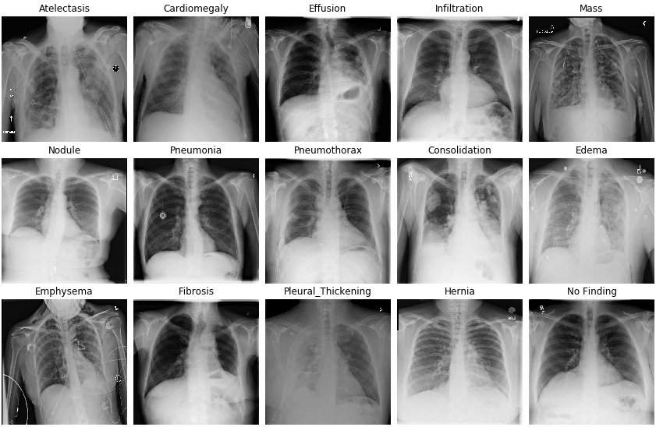

Figure 3.2: Example of different disease in ChestX-ray 14 dataset.

**Japanese Society of Radiological Technology (JSRT) dataset** is the collection of 247 CXR from 14 medical centers [29]. All CXR images have a size of 2048 × 2048 pixels and a gray-scale color depth of 12 bits. Among the 247 CXRs, 93 CXRs are normal and 154 CXRs are diagnosed with lung nodules. All the nodule case are either within lung boundary or subtle so that the effects on lung boundary is minor. Base on JSRT, [32] provided the manually segmented mask.

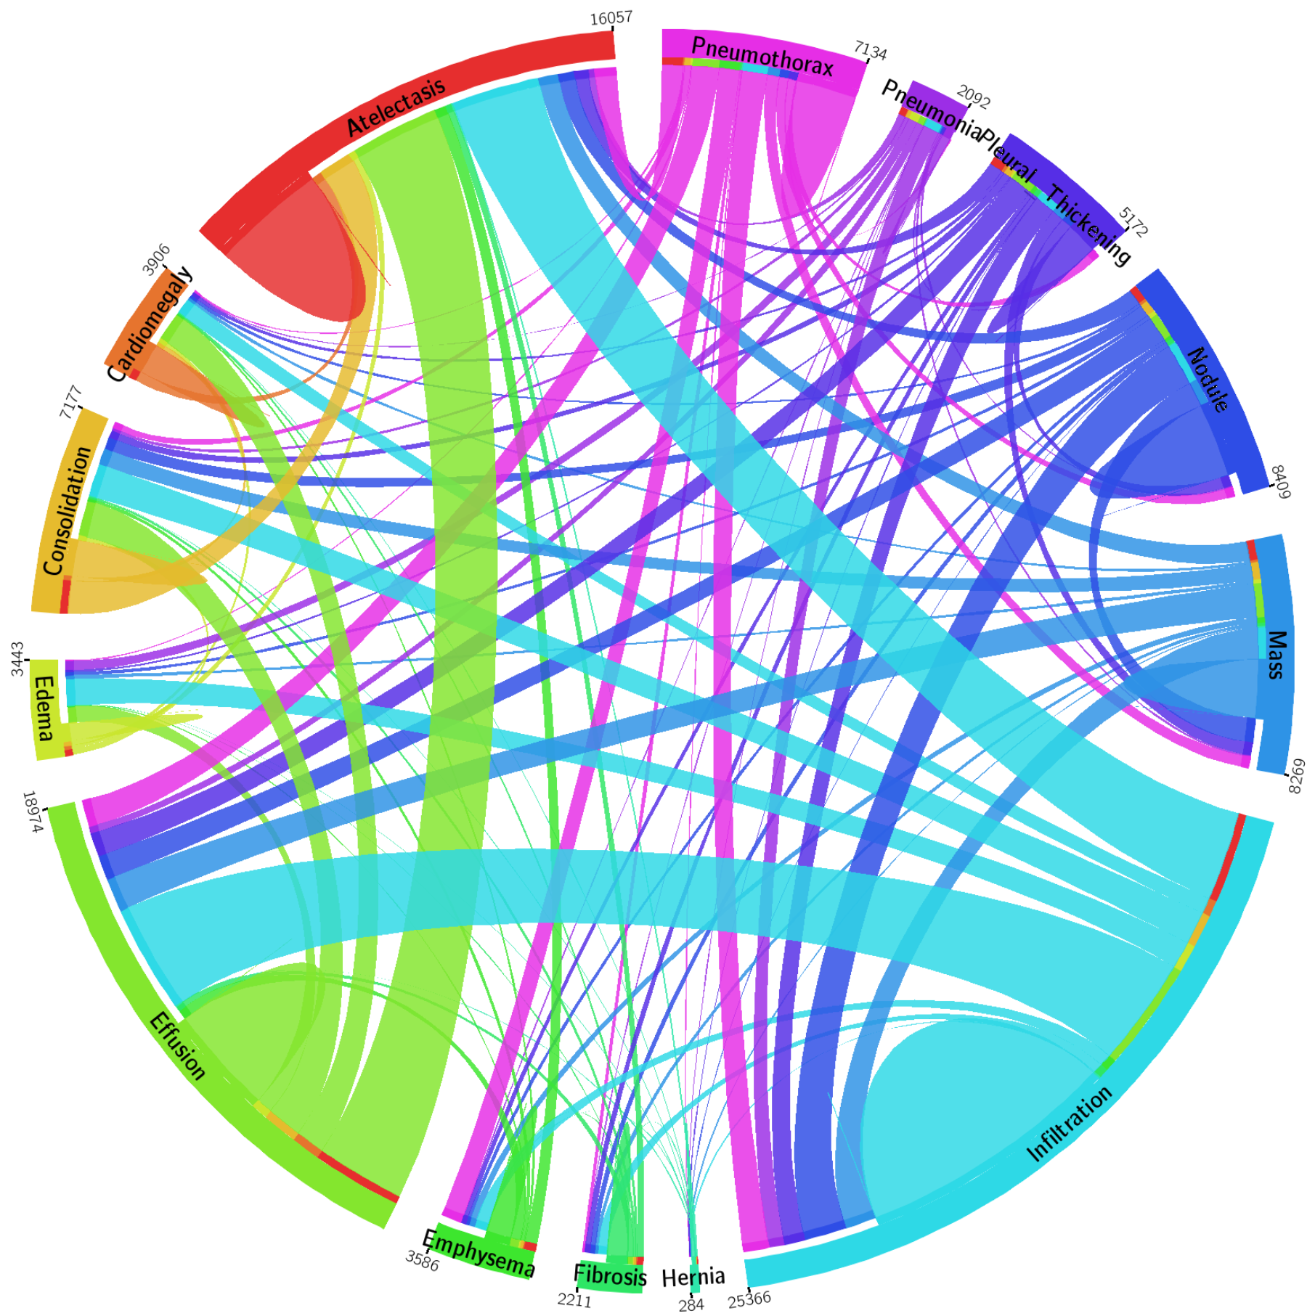

Figure 3.3: The circular diagram shows the proportions of images with multi-labels in each of 14 pathology classes and the labels’ co-occurrence statistics in ChestX-ray 14 dataset.

**Montgomery County (MC) dataset** [33] is the collection of 138 CXR from Department of Health and Human Services, Montgomery County, Maryland. All CXRs is either 4020x4892 or 4892x4020 and a gray-scale color depth of 12 bits. Among 138 CXRs, 80 CXRs are normal and 58 CXRs are diagnosed with tuberculosis. All segmentations are provided as a part of the dataset.

We combined JSRT and MC dataset together to form the training dataset. The training dataset contains 70% of JSRT, 70% of MC for training and 10% of JSRT, 10% of MC for validation. The remaining 20% of JSRT and 20% of MC are used for testing.

## Thorax Classification

In this study, we leveraged ResNet-50 [13] and DenseNet-121 [14] for thorax classification, we also modified the ResNet-50 for Lung Segmentation task.

### ResNet

ResNet [13] is a family of networks that instead of letting the layer learn the direct mapping function, ResNet uses the shortcut connection to explicitly learn the residual mapping. In a traditional convolutional neural network (CNN), the input image usually goes through a sequence of convolutional and pooling to squeeze the width and height dimension white increase the feature depth. The purpose of these stacked convolutional and pooling layers is to learn the features representation of the image. The learned features will be then the input to the fully connected layers for classification. In many early architectures, people had tried to stack more and more convolutional and pooling layers together, hence the term Deep Learning, with an assumption that a deeper network will learn better representation. However, in practice, this design suffers from vanishing gradient problem and the performance degraded as the network get deeper.

Let $x_{l}$ is the input to the $l^{th}$ layer. In traditional CNN, the direct non-linear mapping function $H_{l}$ is computed from previous layer output $x_{l-1}$:

|  |  |  |
| --- | --- | --- |
|  | $$x_{l}=H_{l}(x_{l-1})$$ | (1) |

Where $H_{l}$ is a convolutional layer follow by rectified linear unit (ReLU) [34], batch normalization [35] and often dropout [36]. ResNet address the challenge of training deep network by using skip connection. Instead of learning the direct mapping $H_{l}$, ResNet learns the residual mapping by adding the identity mapping of the input.

|  |  |  |
| --- | --- | --- |
|  | $$x_{l}=H_{l}\left(x_{l-1}\right)+ x_{l-1}$$ | (2) |

This reformulation has several interesting implications. First, the layer now does not explicitly learn the direct mapping but instead learn the residual mapping $H_{l}$. And since residual is the error of the result, that means if the $x_{l-1}$ is the optimal mapping, the layer simply learn to output 0. That makes a deep network shallow. Second, this shortcut connection also helps the gradient to flow back more easily during backpropagation, since the gradient does not have to flow through ReLU layer.

Table 3.2 shows the architecture of ResNet-50 we used in this study. The first layer we used a big convolutional filter of size $7×7$ to capture a large receptive field. Then max pool layer reduces the spatial dimension of the feature maps by haft. Each of the ResBlock then learns to extract more complex features. Finally, the extracted representations are squeezed by an adaptive pool before classification. Figure 3.5 and Figure 3.4 show the low-level building block of ResNet, both layers have 3 contiguous convolutional filters. The first 1 $×1$ convolutional filter help reduces the computational complexity of the model. The shortcut connection has 1 $×1$ filter to ensure dimension matching and performs identity mapping on the input. An interesting note is that ResNet uses a convolutional filter to down sample feature map instead of max pooling. Figure 3.6 shows the complete architecture of ResNet-50 with the dimension of each feature map.

|  |  |  |
| --- | --- | --- |
| Layer name | Input Size | Convolutional Filter size |
| Conv | 3@224 $×$ 224 | $$7×7, 64, s=2, p=3$$ |
| Max Pool | 64@112 $×$ 112 | $$2×2, s=2$$ |
| ResBlock | 64@56 $×$ 56 | $$\left[\begin{matrix}1×1, 64, s=1,p=0 \\ 3×3, 64,s=1,p=1 \\ 1×1, 256, s=1,p=0\end{matrix}\right]×3$$ |
| ResBlock | 256@56 $×$ 56 | $$\left[\begin{matrix}1×1, 128, s=1,p=0 \\ 3×3, 128,s=1(2),p=1 \\ 1×1, 512, s=1,p=0\end{matrix}\right]×4$$ |
| ResBlock | 512@28 $×$ 28 | $$\left[\begin{matrix}1×1, 256, s=1,p=0 \\ 3×3, 256,s=1(2),p=1 \\ 1×1, 1024, s=1,p=0\end{matrix}\right]×6$$ |
| ResBlock | 1024@14 $×$ 14 | $$\left[\begin{matrix}1×1, 512, s=1,p=0 \\ 3×3, 512,s=1(2),p=1 \\ 1×1, 2048, s=1,p=0\end{matrix}\right]×3$$ |
| Adaptive Pool | 2048@7 $×$ 7 | $$7×7, s=7$$ |
| Fully Connected | 2048@1 $×$ 1 | $$2048×14$$ |

Table 3.2: ResNet-50 architecture. 7×7, 64, s=2, p=3 denotes this layer has 64 filters with size 7×7, stride = 2 and padding = 3. 3@224×224 means width and height is 224, 3 channels. The number 50 denotes the total number of convolutional filter and fully connected filter.

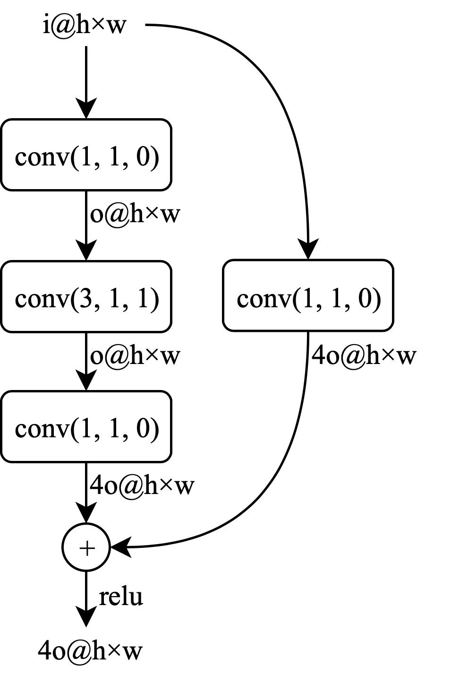

Figure 3.4: **Residual Layer**: the convolution on shortcut path perform linear mapping to ensure dimension matching.

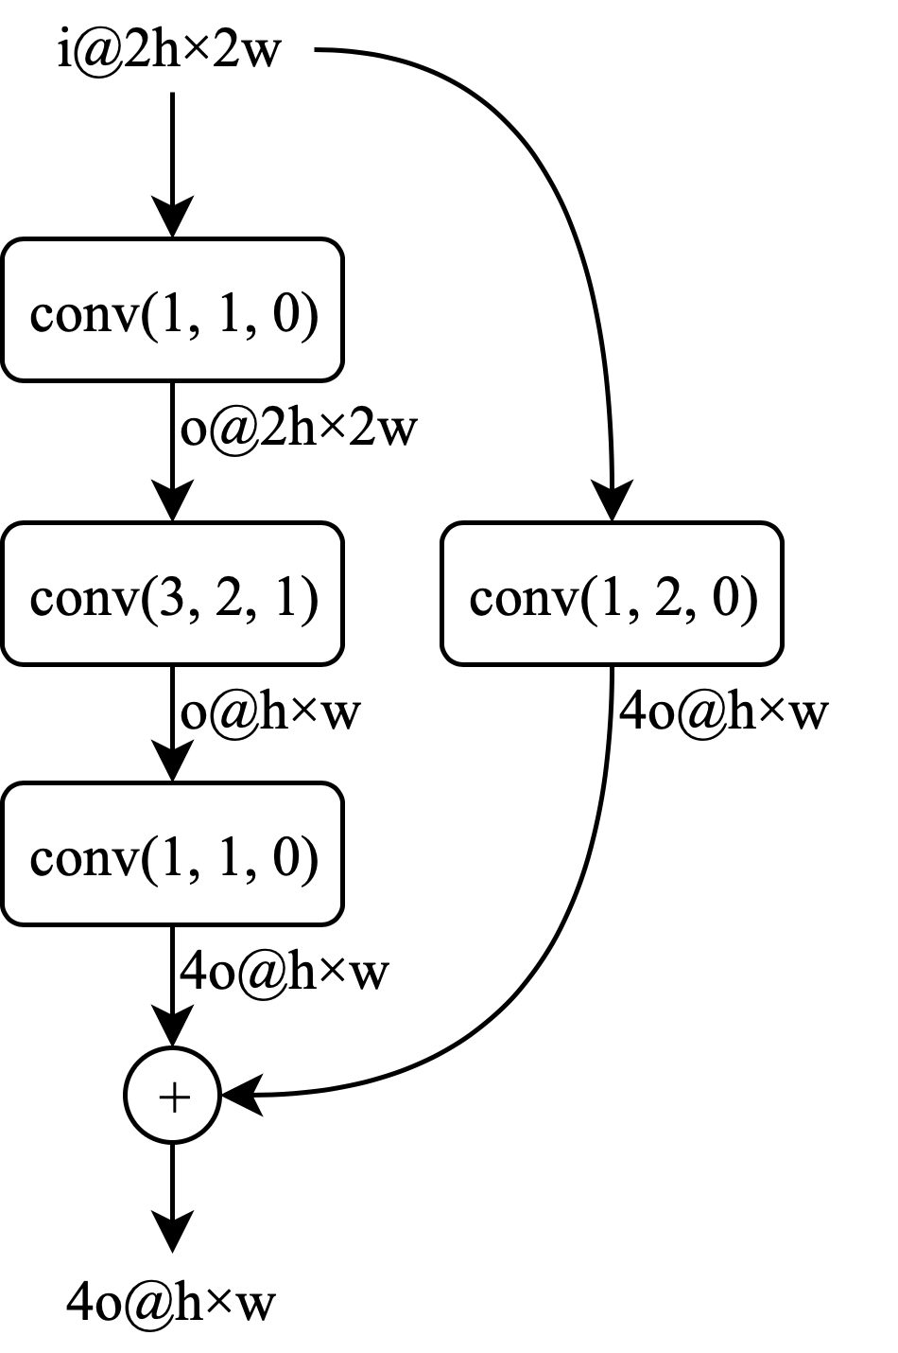

Figure 3.5: **Down Layer**: Instead of using pooling layer to down sample, ResNet family use convolution filter with **stride = 2** to do the jobs. This layer is identical to the ResLayer except for the stride of the middle convolution.

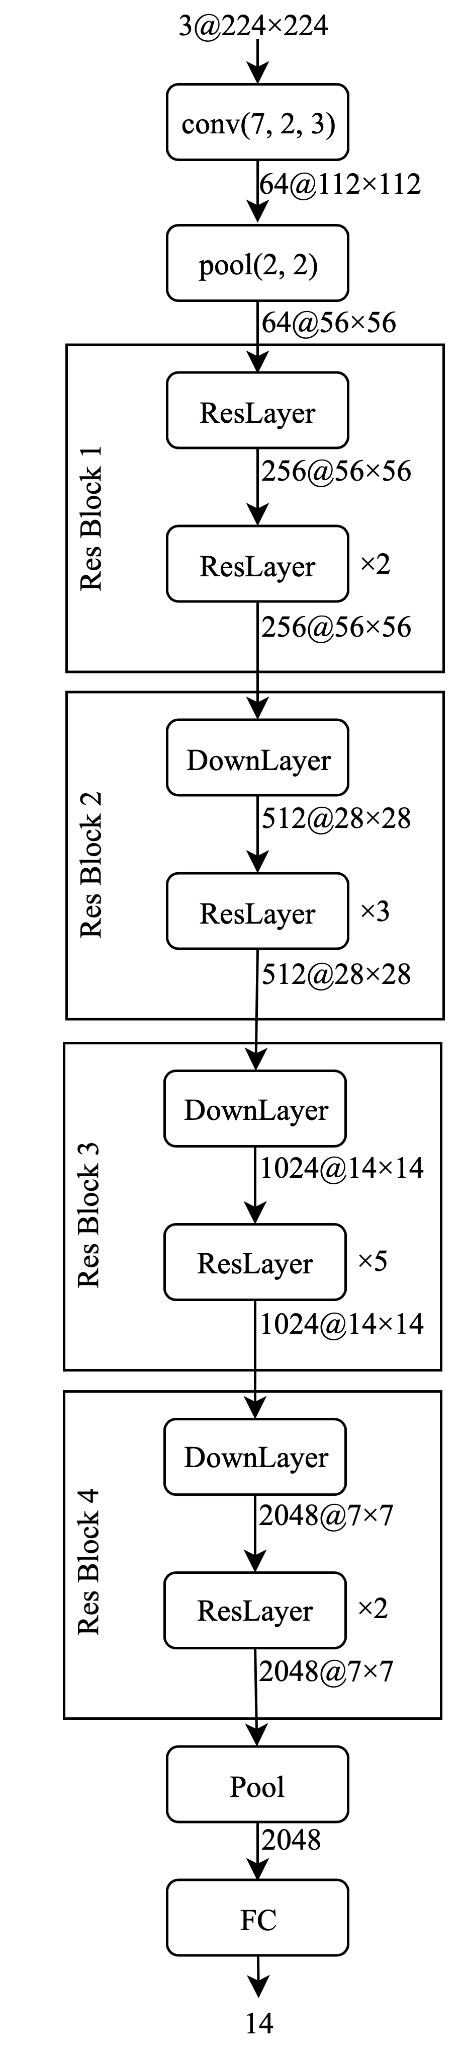

Figure 3.6: Visualize the **ResNet-50** architecture.

### DenseNet

DenseNet [14] pushed the idea of residual connection by iteratively concatenate all previous feature:

|  |  |  |
| --- | --- | --- |
|  | $$x_{l}=H_{l}\left({[x}_{l-1},x_{l-2}, …,x_{0}]\right)$$ | (3) |

Where $[…]$ represents the concatenate operation. This small modification has led to several interesting results. First, layer parameters efficiency: each layer is fine-tuned on all preceding features map, this implies that the parameters in each layer are learned more efficiently. Second, reduce the number of parameters: since each parameter is used more efficiently, the model has significantly fewer parameters than ResNet for the same performance. Third, feature reuse: output feature map is cascaded to all lower layers, this implies that the feature map is reused again and again. Fourth, better gradient flow: when backpropagation, all layers within Dense Block has direct access to the gradient from the last layer, leading to a much deeper network and faster training time. However, concatenation of feature map leads to linear growth in the number of feature maps. This implies that DenseNet consumes more memory than ResNet.

Table 3.3 shows the architecture of DenseNet-121 used in this study. Each DenseBlock is the composition of several convolutional layers to learn the representation mapping. The transition layer is added to reduce spatial dimension just like max pool layer in ResNet. Figure 3.7, Figure 3.8 shows the low-level building block of DenseNet. In Figure 3.7, we concatenate the identity mapping with the output from convolutional layer instead of adding like in ResNet. In Figure 3.8, the first $1×1$ convolutional filter reduces feature depth while the pool layer reduces feature width and height. Figure 3.9 visualizes DenseBlock, this layer uses a lower level layer in Figure 3.7, the number of feature growth linearly with the factor of 32 after each layer. Figure 3.10 visualizes the whole architecture of DenseNet-121.

|  |  |  |
| --- | --- | --- |
| Layer name | Input Size | Convolutional Filter size |
| Conv | 3@224 $×$ 224 | $$7×7, 64, s=2, p=3$$ |
| Max Pool | 64@112 $×$ 112 | $$2×2, s=2$$ |
| Dense Block | 64@56 $×$ 56 | $$\left[\begin{matrix}1×1,s=1,p=0 \\ 3×3,s=1, p=1\end{matrix}\right]×6$$ |
| Transition | 256@56 $×$ 56 | $$\left[\begin{matrix}1×1 \\ 2×2 pool, s=2\end{matrix}\right]$$ |
| Dense Block | 128@28 $×$ 28 | $$\left[\begin{matrix}1×1,s=1,p=0 \\ 3×3,s=1, p=1\end{matrix}\right]×12$$ |
| Transition Block | 512@28 $×$ 28 | $$\left[\begin{matrix}1×1 \\ 2×2 pool, s=2\end{matrix}\right]$$ |
| Dense Bock | 256@14x14 | $$\left[\begin{matrix}1×1,s=1,p=0 \\ 3×3,s=1, p=1\end{matrix}\right]×24$$ |
| Transition | 1024@14x14 | $$\left[\begin{matrix}1×1 \\ 2×2 pool, s=2\end{matrix}\right]$$ |
| Dense Block | 512@7 $×$ 7 | $$\left[\begin{matrix}1×1,s=1,p=0 \\ 3×3,s=1, p=1\end{matrix}\right]×16$$ |
| Adaptive Pool | 1024@7 $×$ 7 | $$7×7, s=7$$ |
| FC | 1024@1 $×$ 1 | $$1024×14$$ |

Table 3.3: Densenet-121 Architecture. 7×7, 64, s=2,p=3 denotes this layer has 64 filters with size 7×7, stride = 2 and padding = 3. The number 121 denotes total number of convolutional filter and fully connected filter.

Figure 3.7: **Dense Layer** concatenates the result with the input.

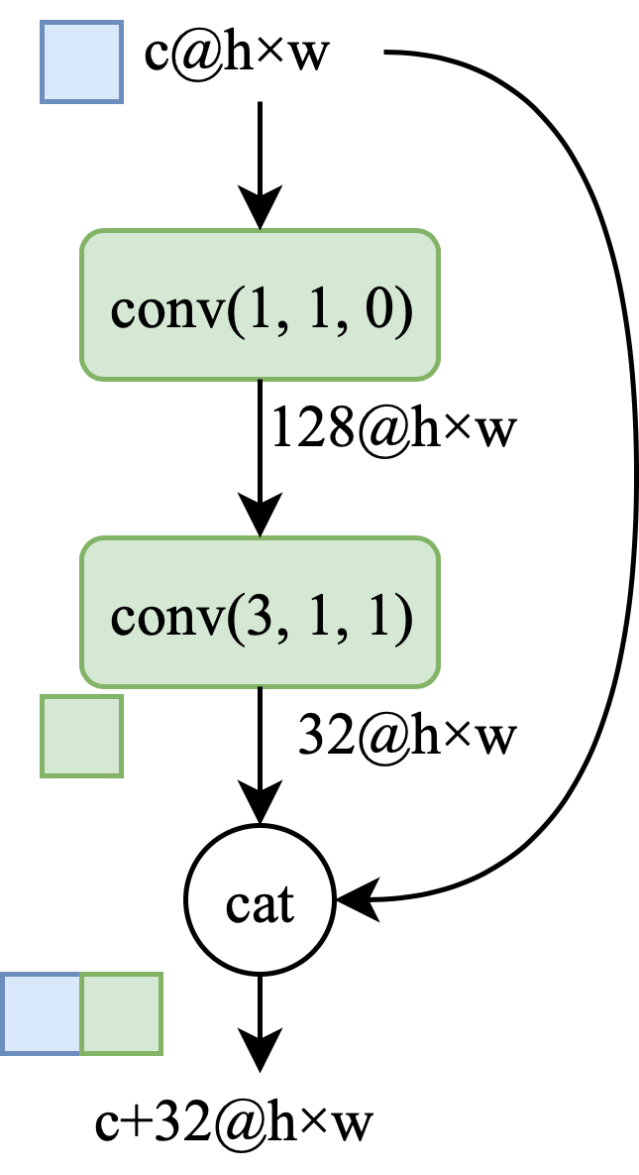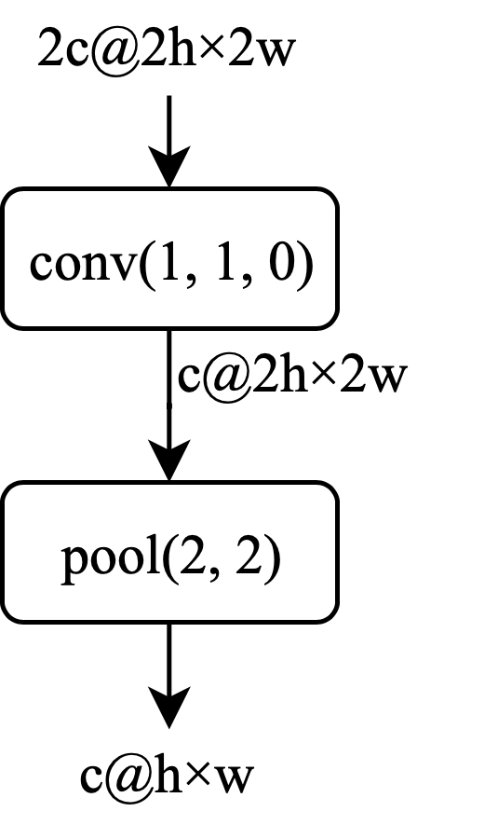

Figure 3.8: **Transition Block**: 1×1 convolution follow by 2×2 pooling layer to decrease the spatial dimension of the feature maps.

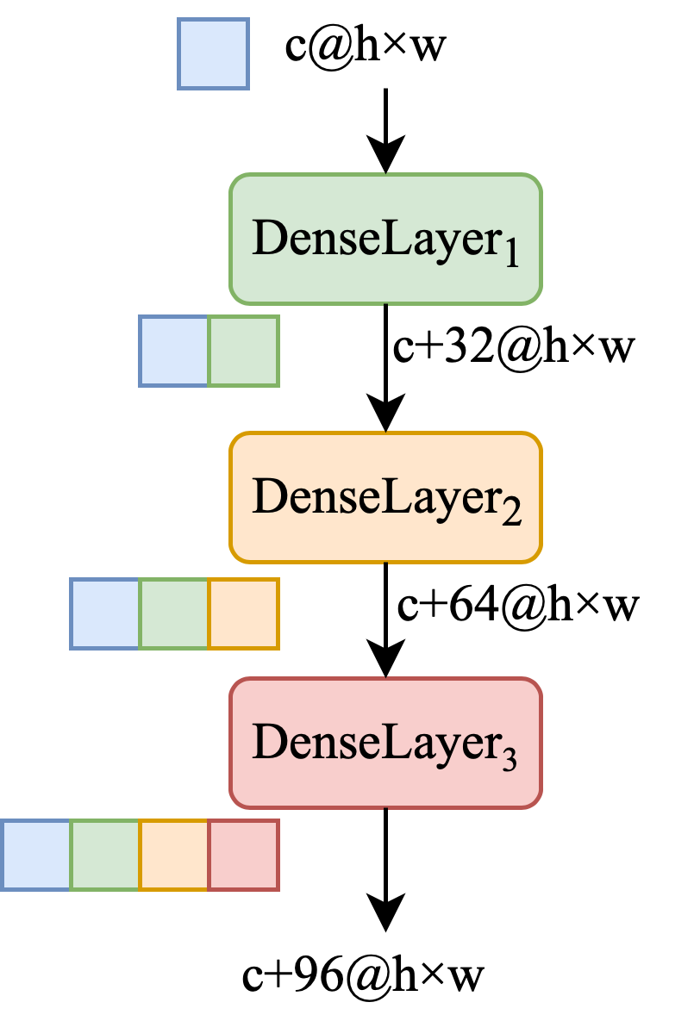

Figure 3.9: **Dense Block**: Each Dense Layer learns the mapping for the input and concatenates with the input. So that every proceeding layer has direct access to all the output of all preceding layer. Dense Block with n Dense Layers will transform the input from c channels to **c+32n** channels.

Figure 3.10: Visualizing **Densenet-121** architecture.

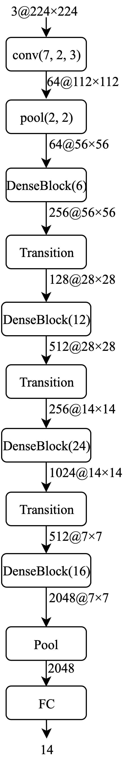

## Lung Segmentation

The goal of semantics segmentation is to label every pixel in the image. This is more challenging than classification, where the classifier only learn “WHAT” object is in the image. Segmentation requires the model not only learns about “WHAT” object but also learn about “WHERE” the object is. In this study, our task was to segment the lung region from the CXR image. Given a CXR, we have to output a binary mask where lung pixels are 1 and other pixels are 0.

We tackled this by using Unet [27] architecture and apply it to ResNet [13]. The network composes of 2 paths: the down-sampling path and the up-sampling path, or also known as encoder and decoder. In the encoder stage, we used ResNet-34 as a backbone to extract features from the image. Then from these latent features, the decoder path will learn to reconstruct the high-resolution binary mask.

We use transposed convolution (also known as up convolution) to learn the up-sampling path. This approach allows the model to learn a more flexible up-sampling transformation compare to other fixed strategy methods. However, the down-sampling path uses max pool layer, which discards the spatial information from the features map, so we also add short-cut connection inspire by Unet. After each transpose convolution, we will concatenate the feature map from the equivalent down-sampling path that brings in spatial information to help in the reconstruction of the fine-grained segmentation.

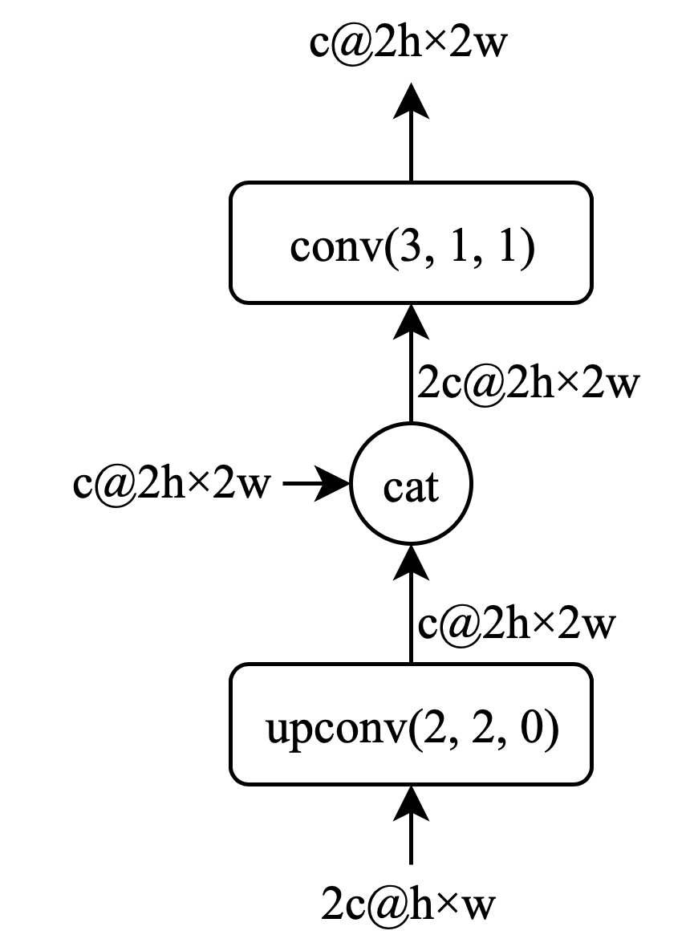

Figure 3.11: **Up Layer:** This layer will restore the resolution of the input image with the feature from decoding path.

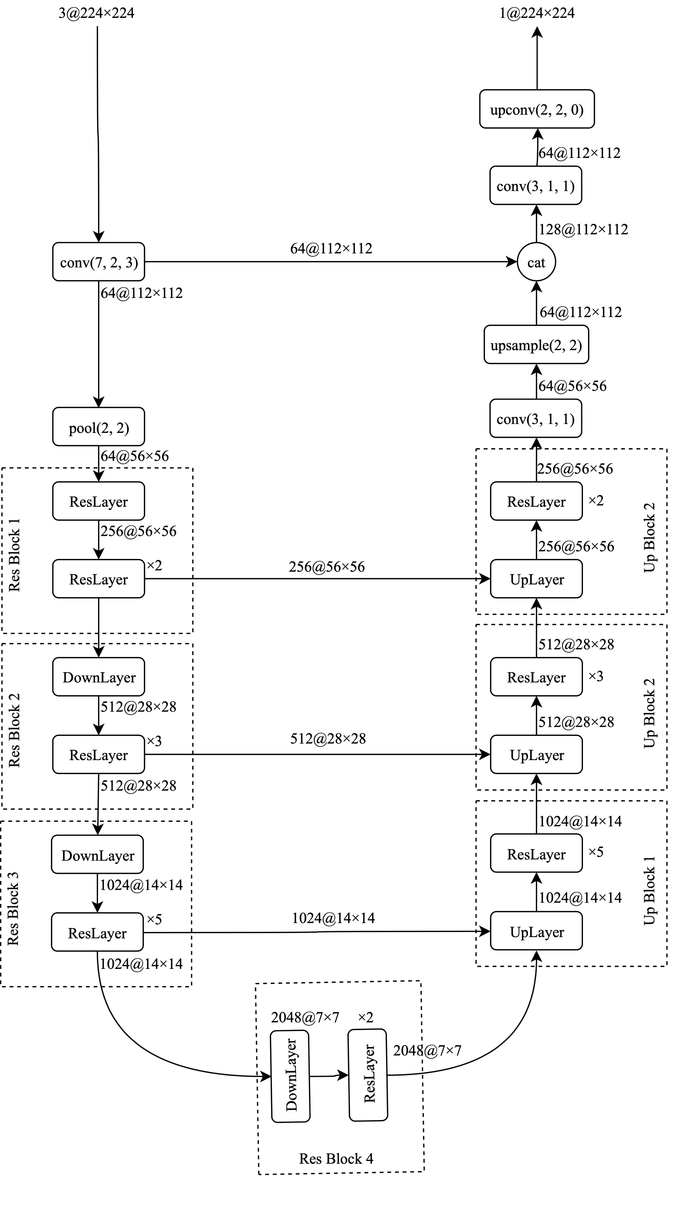

Figure 3.12: Unet with ResNet-50 as the backbone to do lung segmentation task. The down-sampling path is identical to the ResNet-50 that will encode the information. The up-sampling path will learn to decode the features map to reconstruct the input resolution with skip.

## Loss Function

In DL, loss function (also known as objective function) is a mathematical formula that describes the penalty given to a model when it makes a wrong decision. We use the loss function to optimize the parameter of the model so that it fits better to the data. Lung segmentation and thorax classification can be seen as a classification problem, so we will use Binary Cross Entropy Loss as baseline loss to develop our objective functions.

### Lung Segmentation:

We formalize the segmentation problems as pixel-wise classification where each pixel is label as lung region or not. Let $y∈R^{W×H}$, $y_{i,j}= 1$ indicates lung region and 0 otherwise, let $p∈R^{W×H}$ which $p_{i, j}$ indicates the probability of pixel $y_{i,j}$ is lung region. W, H is the width and height of the input image and ground truth mask.

Using the above setting, the loss function is equal to the total binary cross entropy loss for every pixel in CXR.

|  |  |  |
| --- | --- | --- |
|  | $$L(p, y)=\sum_{i=0, j=0}^{i∈H,j∈W}{-y_{i, j}ln⁡(p)}+\sum_{i=0, j=0}^{i∈H,j∈W}{(1-y_{i, j})ln⁡(1-p)}$$ | (4) |

### Thorax classification:

In CXR, multiple thorax diseases can appear at the same time, making it’s a multi-label problem. To represent multi-label setting, let a 14-dimension label vector $y=\left[y_{1},y_{2}, …, y_{c}, …, y_{C}\right]$ where $y_{c}=1$ indicates the represent of pathology c and $y_{c}=0$ otherwise, let $p=\left[p_{1},p_{2}, …, p_{c}, …, p_{C}\right]$ where $p_{c}$ indicates the probability of pathology c. $C=14$ is all possible pathology in the dataset. This means an all-zero vector $y=\left[0, 0, …, 0\right]$ represent “No Finding” status (no pathology in the scope of 14 diseases is found in this sample). This setting transits the multi-label classification problem into 14 independent binary classification problems.

Using the above setting, the loss function is equal to the total binary cross entropy loss for each possible pathology. And since the image labels are rather spare (i.e., more ‘0’s than ‘1’s), the positive/negative balancing factor $β_{P}, β_{N}$ is introduced to enforce the learning of positive labels.

|  |  |  |
| --- | --- | --- |
|  | $$L(p, y)=β_{P}\sum_{{c=1, y}_{c}=1}^{c=14}{-ln⁡(p)}+β_{N}\sum_{n{c=1, y}_{c}=0}^{c=14}{-ln⁡(1-p)}$$ | (5) |

$β_{P}=\frac{\left|P\right|+|N|}{|P|}$ is positive balancing factor, $β_{N}=\frac{\left|P\right|+|N|}{|N|}$ is negative balancing factor where |P| and |N| is the total number of ‘1’s and ‘0’s in a batch of image labels.

## Learning rate finder

Learning rate is a crucial hyper-parameter that make the model learn well. If the learning rate is too low, the model could find hard to converge quickly, lead to long training time. If the learning is too high, the model could not converge at all. To find an appropriate learning rate, we adopt the Learning Rate Finder technique mention in [37]. The idea is to exponentially increase the learning rate from a low rate (1e-8) to large rate (10) and record loss in the process, then plot the learning rates again the losses. A just-right learning rate could be spotted in the graph when the loss falling fast and before it becomes divergence.

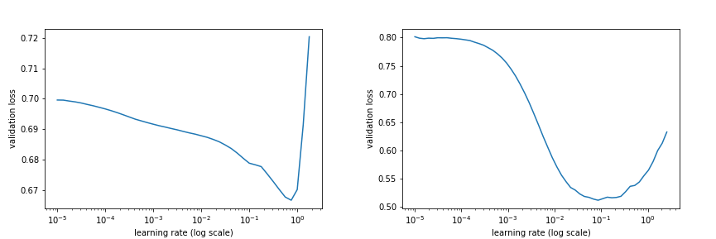

Figure 3.13: **Left**: Learning rate finder for lung segmentation, here we choose a learning rate of 1e-2. **Right**: Learning rate finder for ChestX-ray 14 dataset, here we choose a learning rate of 1e-3.

## Training setting

### Lung Segmentation:

We use Resnet-50 [13] with pretrained weight from ImageNet [12] as the backbone for our lung segmentation. We use Adam optimizer [38] to update the model weight. The initial learning rate is set to 1e-2 for up-sample branch and 1e-3 for Resnet-50 backbone. The model was trained for 20 epochs using Cyclic Learning Scheduler [37] and choose the best model with the lowest validation loss. Before inputting to the model, we downscale the image to 256x256 and normalize base on the mean and standard deviation of training images in ImageNet. We also applied random horizontal flipping, adjust brightness and small rotation.

### Thorax Classification:

We use DenseNet-121 [14] with pretrained weight from ImageNet as the backbone for our classification. We use Adam optimizer [38] with default hyper-parameter (β1=0.9,β2=0.999) and initial learning rate 1e-3 with decay by 10 each time validation loss is not improved. The model is trained for 100 with a batch size of 32 and choose the best model with the lowest validation loss. Before inputting to the model, we downscale the image to 256x256, then take a random crop of 224x224 and normalize base on the mean and standard deviation of training images in ImageNet. We also applied random horizontal flipping, adjust brightness and small rotation.

# Result

## Hyperparameter tuning

Hyperparameter tuning is an essential part of training Deep Learning (DL) model. We conducted several experiments to find the best set of hyperparameters for training the model. The experiment included:

* Training using different learning rate
* Training using different batch size
* Training using for longer

### Different learning rate

Learning rate is the step size the model takes for each optimization step. High learning rate leads to unstable and potential divergent training. Low learning rate leads to longer convergent time. We experimented with different learning rate ranging from 1e-6 to 1e-2 with the exponential step size.

In Figure 4.1, when the learning rate is 1e-6, the learning progressed very slowly. When the learning rate is 1e-2, the learning progress cannot convergent. From this experiment, we have chosen the learning rate to be 1e-3.

### Different batch size

Batch size is the number of images needed for each optimization step. We experimented with different batch size ranging from 16 to 128 with the exponential step size.

In Figure 4.2, bigger batch size did help the training process. However, when the batch size excessed 64, there is no more benefit for bigger batch size. From this experiment, we have chosen the batch size to be 64.

### Training longer

Epoch is when we iterate over the entire training set, longer epoch gives the model the necessary time to converge. We experiment with different epoch ranging from 100 to 500 with a step size of 100.

In Figure 4.3, we can see that the model loss and performance plateau after 100 epochs. From this experiment, we have chosen the epoch to be 100.

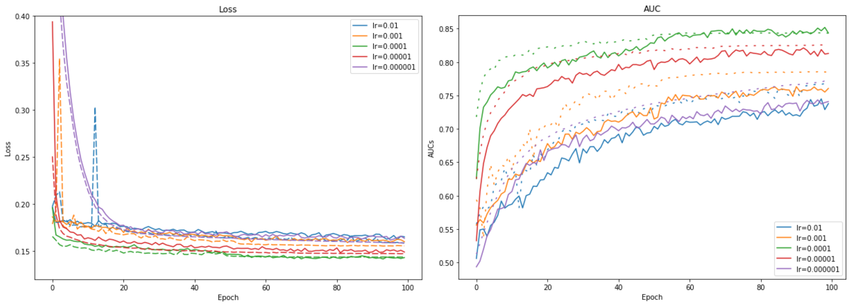

Figure 4.1: **Left**: Loss for different learning rates, **Right:** AUC for different learning rates. Different experiments were color-coded, the solid line shows the training result, the dashed line shows the validation result. Learning rate is denoted as lr.

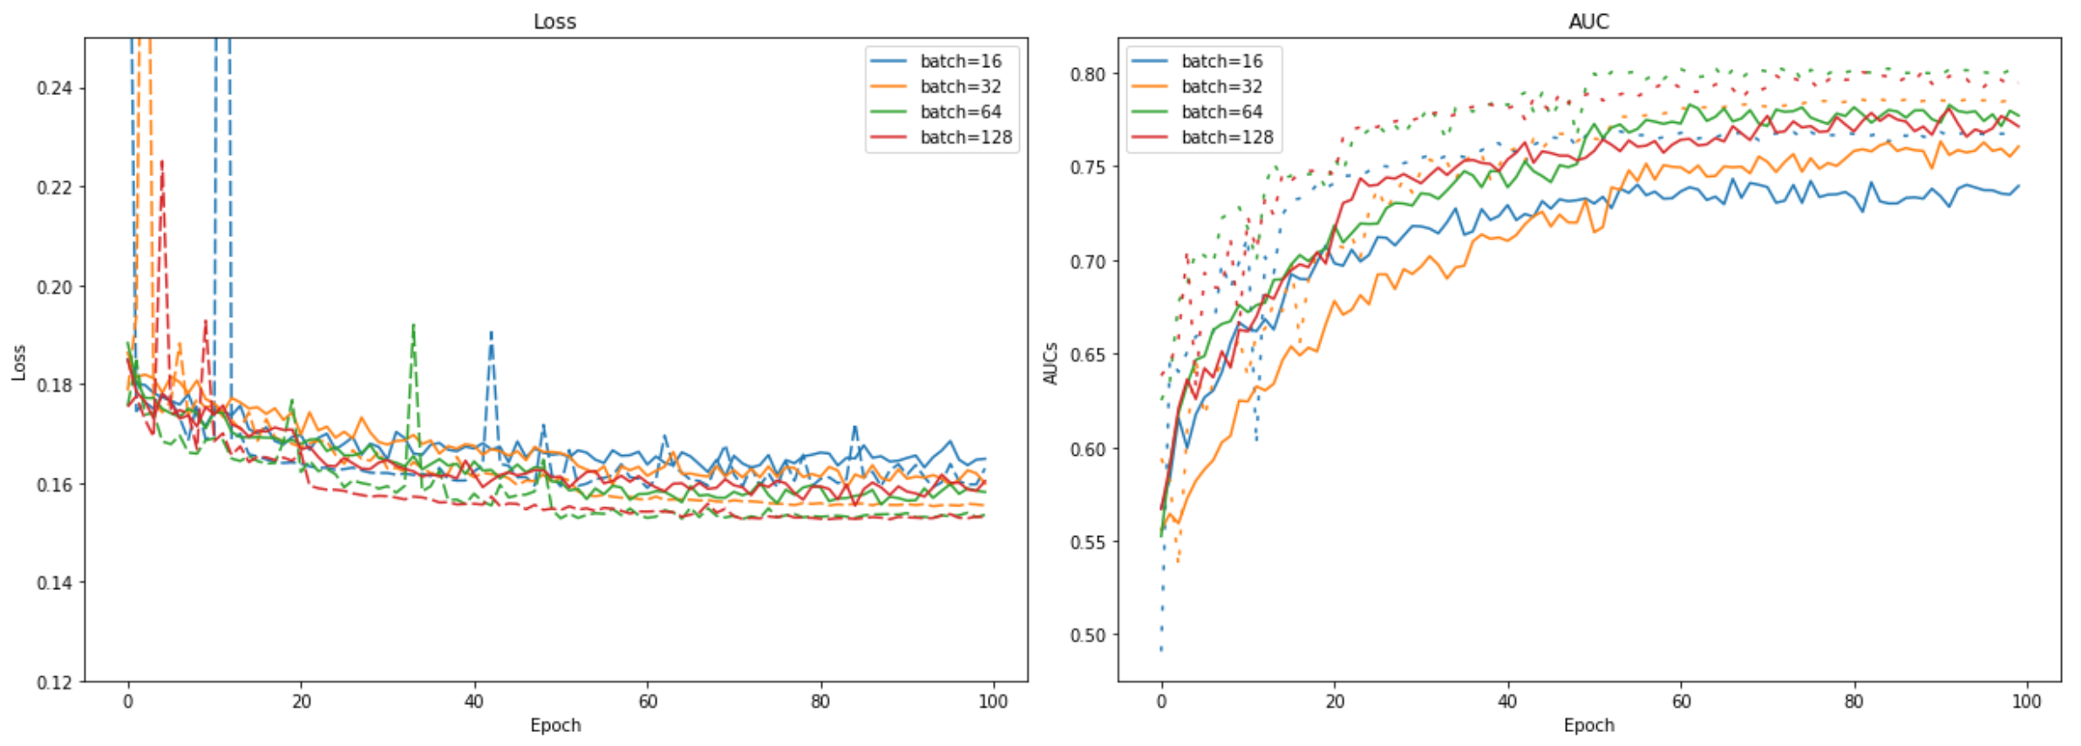

Figure 4.2: **Left**: Loss for different batch sizes, **Right:** AUC for different batch sizes. Different experiments were color-coded, the solid line shows the training result, the dashed line shows the validation result.

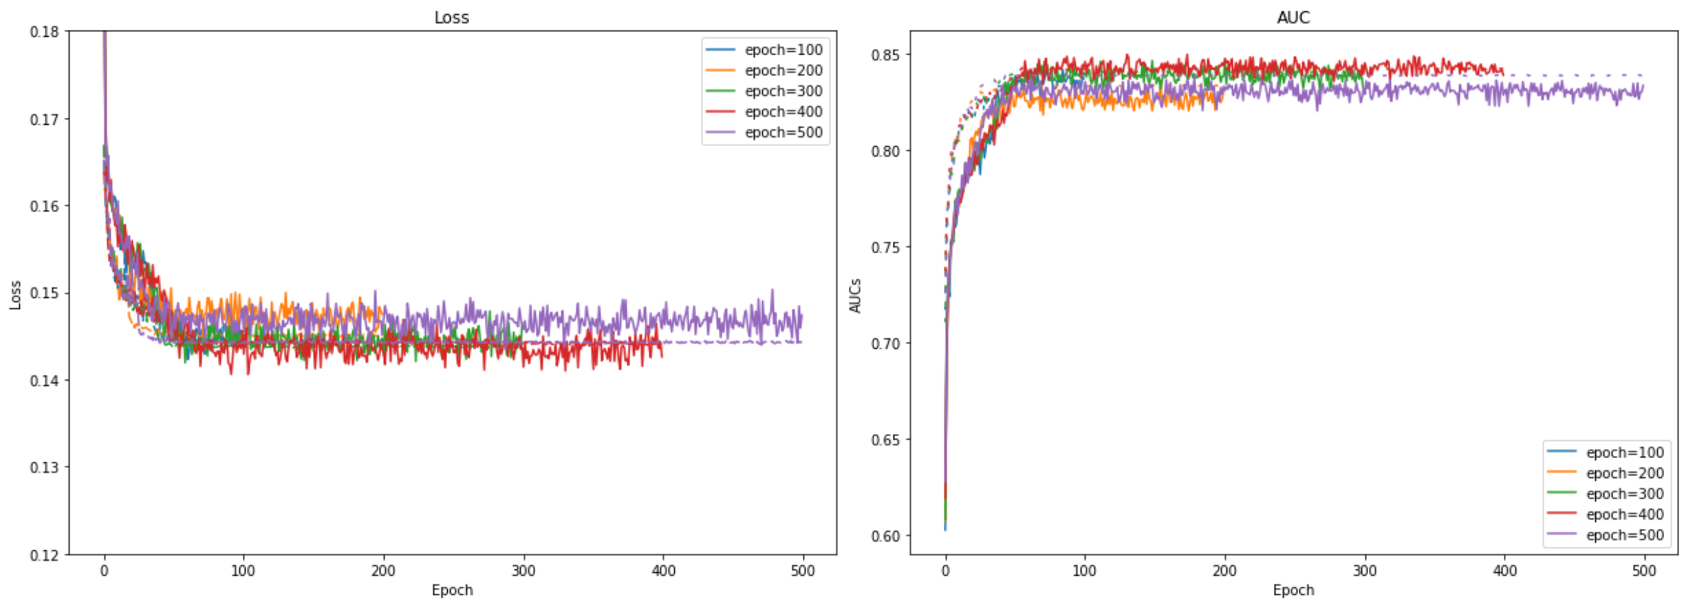

Figure 4.3: **Left**: Loss for different epochs, **Right:** AUC for different epochs. Different experiments were color-coded, the solid line shows the training result, the dashed line shows the validation result.

## Lung Segmentation

To evaluate lung segmentation, we use two different metrics:

* The Jaccard Similarity Coefﬁcient: Also known as Intersection over Union (IoU):

|  |  |  |
| --- | --- | --- |
|  |  | (6) |

Where y is ground truth mask, p is estimated mask, *TP (True Positive)* represents the number of correctly classify pixel, *FP (False Positive)* represents pixel classify as lung region but is not*, FN (False Negative)* represents pixel that is lung region but is not classify so.

* Dice’s coefficient:

|  |  |  |
| --- | --- | --- |
|  |  | (7) |

Table 4.1 shows the results on JSRT and MC test set, while Table 4.2 shows our result compare to related works in literature.

|  |  |  |
| --- | --- | --- |
| Dataset | Dice | IoU |
| JSRT | 0.969 | 0.919 |
| MC | 0.971 | 0.930 |

Table 4.1: Dice and IoU scores on segmentation task on JSRT on MC dataset

|  |  |
| --- | --- |
| Method | IoU |
| **This study** | 0.919 |
| [25] | 94.1 |
| [28] | 98.6 |

Table 4.2: IoU report in literature on JSRT dataset.

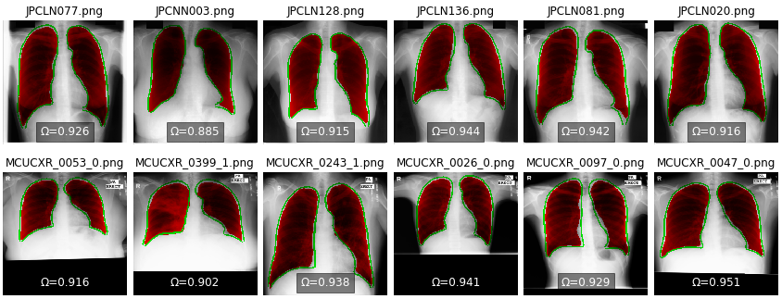

Figure 4.4: Lung Segmentation result on **Top**: JSRT dataset, **Bottom**: MC dataset. The green contour indicates the ground truth and the red mask indicates the predicted mask. Ω denotes the IoU value.

Lung segmentation is not perfect, it sometimes marks small objects as lung region. We used the morphological opening to remove the unwanted objects. The algorithm works by has two stages: erosion follows by dilation. In the erosion stage, the 2d convolutional filter slide through the image, the center pixel is considered 1 if all pixel under the filter is 1, otherwise it is eroded (made to zero object. In the dilation stage, the 2d convolutional filter slide through the image, the center pixel is considered 1 if any pixel under the filter is 1. We used the kernel size of 5 for both erosion and dilation step. We used the largest connected object algorithm to find lung bounding box. We also

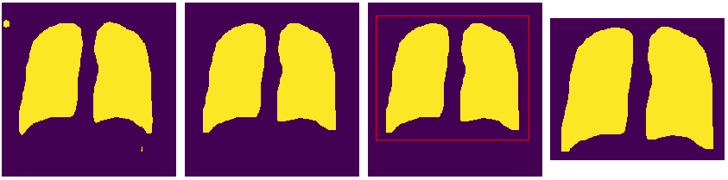

Figure 4.5: Post processing to remove unwanted object and cut the lung region for classification.

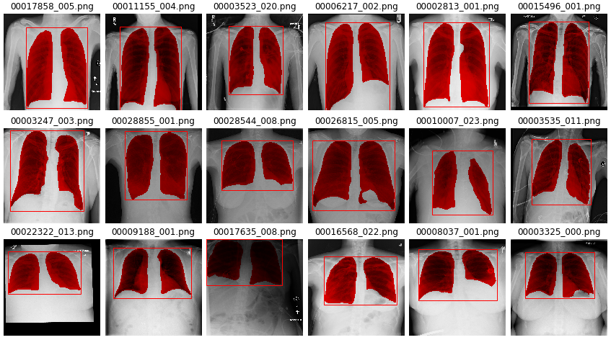

Figure 4.6: Lung segmentation result in Chest X-ray 14 dataset on different lung size. The red mask indicates the predicted lung region, the bounding box is generated from the largest connected component in the binary mask. From the detected bounding box. We calculate the lung ratio (r) as the fraction of lung width over lung height. **Top:** r < 0.8, **Middle:** r ∈[0.8, 1.5], **Bottom:** r > 1.5.

padded the bounding box to allow more context information. Figure 4.5 shows the result of the algorithm. Figure 4.6 shows the segmentation result on lung on ChestX-ray14.

There are some extreme cases where the algorithm failed to segment the lung. There are 2 types of problems that the algorithm failed to do it works. The first is when the algorithm can only detect 1 lung. Other is when 2 lungs were fused together through the apex. There are 67 cases out of 22433 images in the test set. In all of these cases, we used all the image instead.

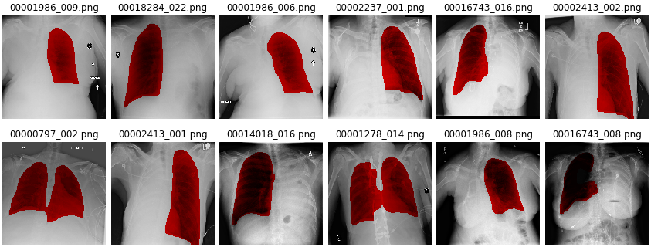

Figure 4.7: Failed case on ChestX-ray 14.

## Thorax Classification

We evaluate the classification result using *Receiver Operating Characteristic (ROC)* graph and *Area Under ROC Curve (AUC)* metric [39], [40] and [41]. The ROC graph is the visualization of classifier performance. The output of the classification model is the probability of having the disease, so for each decision threshold, we can have the following confusion matrix.

|  |  |  |  |
| --- | --- | --- | --- |
|  | | Ground-truth label | |
| Positive | Negative |
| Predict label | Positive | TP | FP |
| Negative | FN | TN |

Table 4.3: Confusion matrix for each individual disease.

If the CXR is positive and the model predicts as positive, it is counted as *TP (True Positive)*, if it is predicted as negative, it is counted as *FN (False Negative)*. If the CXR is negative and the model predicts as negative, it is counted as *TN (True Negative)*, if it is predicted as positive, it is counted as *FP (False Positive)*.

Sensitivity is the percentage of the positive case that the model successfully rule-in. Specificity is the percentage of the negative case that the model successfully rule-out. From the confusion matrix, we can calculate the sensitivity and specificity using the following equation:

|  |  |  |
| --- | --- | --- |
|  | $$sensitivity= \frac{TP}{TP+FN}$$ | (8) |
|  | $$specificity= \frac{TN}{TN+FP}$$ | (9) |

The ROC Curve is plotted with (1-specificity) as the x-axis and sensitivity as the y-axis as the decision threshold varies from 0 (no disease) to 1 (certainly). ROC curve represents the trade-off between sensitivity and specificity. From ROC curve, we can choose a specific operating point. For example, we can choose an operating point with high specificity and low sensitivity to rule-in disease from the early stage of the screening process, we then choose an operating point with high sensitivity and low specificity to rule-out disease in the later stage.

To compare 2 different models, we can use the ROC curve as well. The mode with ROC curve higher to the top-left (high sensitivity and also high specificity) are better. This measurement of expertise can be quantified beautifully using the Area Under ROC Curve (AUC).

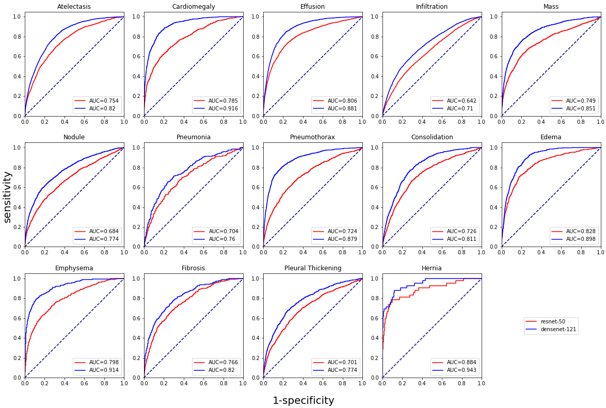

Figure 4.8: Compare ROC for 14 different disease for ResNet-50 and DenseNet-121.

Figure 4.8 shows ROC for each of each of the 14 diseases on ResNet-50 and DenseNet-121 architecture. The figure shows that DenseNet-121 outperformed Resnet-50 on every disease. Figure 4.9 shows ROC for one-stage and two-stage model. The figure shows that the two-stage model did perform better than the one-stage model on Atelectasis, Nodule, Mass and Pleural Thickening. However, for remaining disease, the two-stage model shows little improvement upon on one-stage model.

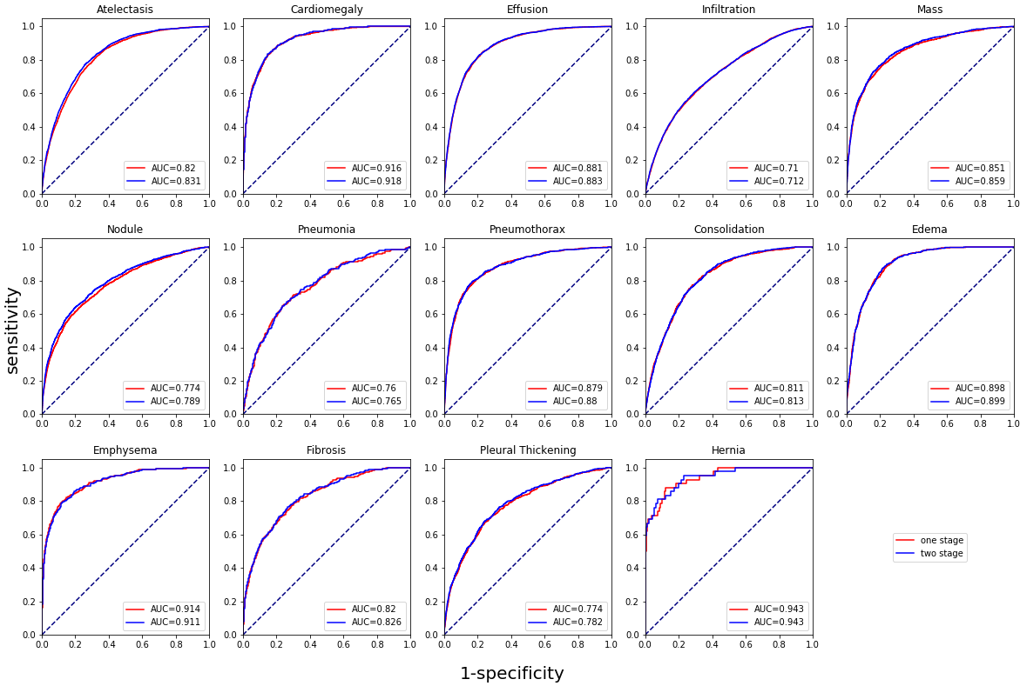

Figure 4.9: Compare ROC for 14 different disease for one stage on two stage model.

Table 4.4 shows the sample output of our system for the top 10 diseases with the highest probabilities on 8 random CXRs. The results would be useful for radiologists to draw their attention to several diseases.

|  |  |  |  |  |
| --- | --- | --- | --- | --- |
| Image |  |  |  |  |
| Prediction | Pneumothorax: 0.996  PT: 0.962  Emphysema: 0.937  Effusion: 0.846  Mass: 0.549  Hernia: 0.310  Atelectasis: 0.257  Consolidation: 0.240  Fibrosis: 0.237  Infiltration: 0.201 | Mass: 0.599  Nodule: 0.538  Edema: 0.442  Infiltration: 0.364  Pneumonia: 0.247  Consolidation: 0.145  Fibrosis: 0.095  PT: 0.094  Effusion: 0.056  Atelectasis: 0.025 | No Finding  Fibrosis: 0.197  Nodule: 0.154  PT: 0.135  Mass: 0.084  Infiltration: 0.078  Atelectasis: 0.053  Effusion: 0.041  Emphysema: 0.040  Pneumonia: 0.018  Consolidation: 0.014 | Emphysema: 0.831  Nodule: 0.250  PT: 0.144  Edema: 0.141  Cardiomegaly: 0.134  Infiltration: 0.092  Pneumothorax: 0.084  Fibrosis: 0.072  Atelectasis: 0.072  Effusion: 0.054 |
| Image |  |  |  |  |
| Prediction | No Finding  Infiltration: 0.254  Nodule: 0.066  Fibrosis: 0.031  PT: 0.023  Mass: 0.016  Atelectasis: 0.015  Pneumonia: 0.010  Emphysema: 0.010  Pneumothorax: 0.008  Effusion: 0.006 | PT: 0.987  Mass: 0.982  Pneumothorax: 0.980  Effusion: 0.962  Consolidation: 0.853  Nodule: 0.649  Infiltration: 0.636  Atelectasis: 0.539  Emphysema: 0.524  Pneumonia: 0.439 | Hernia: 0.906  Atelectasis: 0.771  Consolidation: 0.627  Effusion: 0.471  Cardiomegaly: 0.387  Edema: 0.363  Infiltration: 0.284  Pneumonia: 0.263  PT: 0.141  Emphysema: 0.090 | Edema: 1.000  Infiltration: 0.958  Pneumonia: 0.926  Consolidation: 0.852  Cardiomegaly: 0.837  Effusion: 0.494  Nodule: 0.427  Mass: 0.234  Atelectasis: 0.042  PT: 0.033 |

Table 4.4: Examples of output of the module. We present the top-10 disease with their corresponding probability. The ground truth labels are highlighted in blue. PT represents Pleural Thickening.

## Class Activation Map (CAM)

DL model is usually treated as a black box, this is particularly problematic in a clinical setting where doctors require the model to explain itself. Since the features that the model uses to do the task can be very different from the human. In this study, we used the method of Class Activation Map (CAM) which was proposed by [42] to produce a heatmap of the interesting region to the model and to help the doctor in judging the model output.

To generate a CAM image, an image is first fed into the network and a feature map of the last convolutional layer is extracted. This feature map is then multiplied with the weight of the desired class from the last fully connected layer and added altogether to produce an activation map. The activation map is then blended with the original image to produce the final localized heatmap.

The class activation map is given by the following formula

(Equation 5)

|  |  |  |
| --- | --- | --- |
|  | $$M_{c}=\sum_{k}^{ }{ω_{k}^{c}}f_{k}$$ | (10) |

Where:

* $M_{c}$ activation map for disease c.
* Number of feature map k, k= 1024 for our DenseNet-121
* $ω_{k}^{c}$ weight of last fully connected layer that match the k-th feature to the cth class
* $f_{k}$ feature map at k

Figure 4.10 shows the results of applied CAM technique on 12 random CXRs. The red color indicates the discriminative area where the model used to identify the disease. The result could guide the radiologists’ attention to lung region where the model notice disease features.

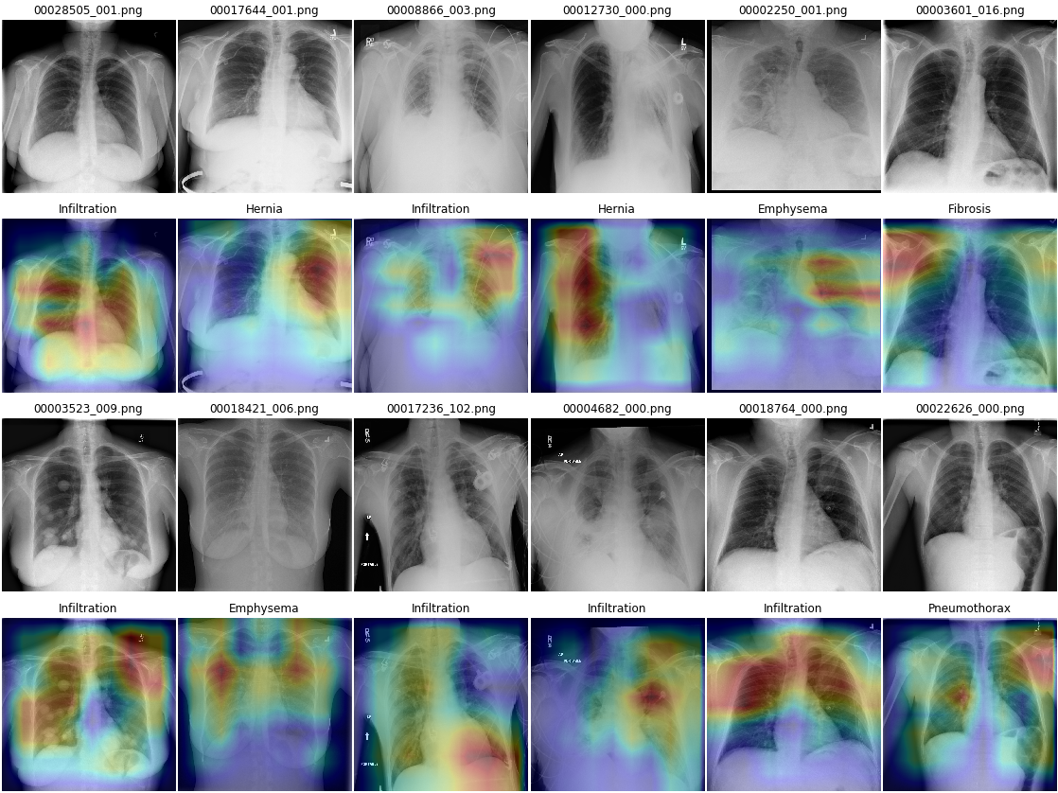

Figure 4.10: CAM for the top-1 disease. The 1st and 3rd row is the original image. The 2nd and 4th row show the CAM result for the top-1 disease.

Some results also point out several problems with our model. First, when the lung is totally invisible, the model cannot detect any features. Second, the model did learn irrelevant features that are outside the lung region.

## Compare to related works in the literature

|  |  |  |  |  |  |  |  |  |  |  |  |  |  |  |  |
| --- | --- | --- | --- | --- | --- | --- | --- | --- | --- | --- | --- | --- | --- | --- | --- |
| Method | Atel | Card | Effu | Infi | Mass | Nodu | Pne1 | Pne2 | Cons | Edem | Emp | Fibr | PT | Hern | Mean |
| [4] | 0.716 | 0.807 | 0.784 | 0.609 | 0.706 | 0.670 | 0.633 | 0.806 | 0.708 | 0.835 | 0.815 | 0.769 | 0.708 | 0.767 | 0.738 |
| [6] | 0.772 | 0.904 | 0.859 | 0.695 | 0.792 | 0.717 | 0.713 | 0.841 | 0.788 | 0.882 | 0.829 | 0.767 | 0.765 | 0.914 | 0.803 |
| [5] | 0.809 | 0.925 | 0.864 | 0.735 | 0.867 | 0.780 | 0.768 | 0.889 | 0.790 | 0.888 | 0.937 | 0.805 | 0.806 | 0.916 | 0.841 |
| [7] | 0.853 | 0.939 | 0.903 | 0.754 | 0.902 | 0.828 | 0.774 | 0.921 | 0.842 | 0.924 | 0.932 | 0.864 | 0.837 | 0.921 | 0.871 |
| **Resnet-50** | **0.754** | **0.785** | **0.806** | **0.642** | **0.749** | **0.684** | **0.704** | **0.724** | **0.726** | **0.828** | **0.789** | **0.766** | **0.701** | **0.884** | **0.754** |
| **One-stage** | **0.82** | **0.916** | **0.881** | **0.71** | **0.851** | **0.774** | **0.76** | **0.879** | **0.811** | **0.898** | **0.914** | **0.82** | **0.774** | **0.943** | **0.839** |
| **Two-stage** | **0.831** | **0.918** | **0.883** | **0.712** | **0.859** | **0.789** | **0.765** | **0.880** | **0.813** | **0.899** | **0.911** | **0.826** | **0.782** | **0.943** | **0.843** |

Table 4.5: Evaluation of different model on ChestX-ray 14 dataset, the performance is reported using the AUC score. Each pathology is denoted with its ﬁrst four characteristics, e.g., Atelectasis with Atel. Pneumonia and Pneumothorax are denoted as Pneu1 and Pneu2, respectively. PT represents Pleural Thickening. For each column, the best and second-best results are highlighted in red and blue, respectively. The results of our experiments are shown in **bold**.

Table 4.5 shows the results of our proposed method compare to various implementations in literature. [4] provided the dataset and a baseline model, [6] used DenseNet as features extractor and Long Short Term memory to exploit label dependencies, [5] used the one-stage model and [7] used three-stage model and outperformed other approaches for almost every disease by a large margin. Our method used a two-stage model and have achieved mean an AUC of 0.843. Our result could be comparable to [5], with each method performed better on different diseases. However, the average performance of our approach was better than [5]. Our method also includes lung segmentation, which is useful for other thoracic tasks. In the other hand, all of the three models in [7] are specifically designed for the classification task, which limits it extensible for other biomedical tasks.

# Conclusion

CXR is the most common medical imaging data available. It plays an important role in the diagnosis of many different lung and heart diseases. The development of a Computer-aided Detection (CAD) which can help the radiologist to make a better decision faster is very important. Our study aimed to create a prediction model that would be the brain of such a system. The proposed Segmentation Guided Thorax Classification (SGTC) has two stages, the lung segmentation stage and the thorax classification stage. In the segmentation stage, Unet was used to segment the lung, from the resulted mask, the region of interest is cut out from the CXR image to use as input for the sub-sequence stages. In the thorax classification stage, we leverage two novel DL model named ResNet-50 and DenseNet-121. The proposed model is then run on ChestX-ray 14 dataset with labels of 14 different lung and heart failures. We have achieved the AUC of 0.843 and also produce Class Activation Map (CAM) that can greatly augment radiologist interpretation.

The result, however, is still far from ready for real-world clinical usage and many more works need to be done. There are several concerns about the ChestX-ray-14 dataset. First, the images had been downscaled from about 2000x3000 pixels to 1024x1024 pixels. In addition, the images also had been heavily reduced in the number of grey-levels from 216 to 28. This reduction in image quality can hurt the model since subtle or small pathology can be missed out. Second, some labels cannot be easily distinguished from a raw CXR, such as “consolidation” and “pneumonia” can have a similar visual appearance. Third, some of the labels ignored the clinical important sub-labels, such as a deadly pneumothorax and a treatable pneumothorax. This can lead the model to learn unimportant or even dangerous thing.

In recent week, there have been 2 large datasets on CXR image released with many similar attributes of ChestX-ray 14 dataset and addressed some of the above issues. The first one, CheXpert [43], contains 224,316 CXRs from 65,240 patients. The second, MIMIC-CXR [44], contains 371,920 CXRs from 224,548 studies. The total number of images is enormous, nearly 1 million CXR publicly available for any researcher. Further study needs to take into account these datasets to make a stronger claim about clinical relevance.

On the model side, the proposed method has many drawbacks. First, segmentation adds an extra layer of complexity to the system, the error of the segmentation stage can be cascaded to downstream stages. Second, the system did not take into account other clinical information such as age and gender distribution. It also did not look at the lateral view, which some pathologies are only visible on lateral projections. Third, the model is trained using only 1 CXR at the times, while in practice, radiologists usually have access to multiple CXRs of the same patient. Further study needs to investigate these issues to check if it improves the result.

While the proposed method gives good result in a controlled setting, it is unclear whether the system can work that well in the real world, uncontrolled clinical environment. In addition, this study did not consider how the radiologists work, and how the system can cooperate and augment their interpretation. We need to address all these issues to create a truly CAD system that can assist radiologist and save patients’ lives.

# Reference

[1] D. Enarson, Respiratory diseases in the world: realities of today - opportunities for tomorrow : forum of international respiratory societies. Sheffield: European Respiratory Society, 2013.

[2] “Vietnam,” Institute for Health Metrics and Evaluation, 09-Sep-2015. [Online]. Available: http://www.healthdata.org/vietnam. [Accessed: 18-Feb-2019].

[3] “In Radiology, Turnaround Time is King | Diagnostic Imaging.” [Online]. Available: https://www.diagnosticimaging.com/practice-management/radiology-turnaround-time-king. [Accessed: 28-Feb-2019].

[4] X. Wang, Y. Peng, L. Lu, Z. Lu, M. Bagheri, and R. M. Summers, “ChestX-ray8: Hospital-scale Chest X-ray Database and Benchmarks on Weakly-Supervised Classification and Localization of Common Thorax Diseases,” ArXiv170502315 Cs, May 2017.

[5] P. Rajpurkar et al., “CheXNet: Radiologist-Level Pneumonia Detection on Chest X-Rays with Deep Learning,” ArXiv171105225 Cs Stat, Nov. 2017.

[6] L. Yao, E. Poblenz, D. Dagunts, B. Covington, D. Bernard, and K. Lyman, “Learning to diagnose from scratch by exploiting dependencies among labels,” ArXiv171010501 Cs, Oct. 2017.

[7] Q. Guan, Y. Huang, Z. Zhong, Z. Zheng, L. Zheng, and Y. Yang, “Diagnose like a Radiologist: Attention Guided Convolutional Neural Network for Thorax Disease Classification,” Jan. 2018.

[8] H.-C. Shin, K. Roberts, L. Lu, D. Demner-Fushman, J. Yao, and R. M. Summers, “Learning to Read Chest X-Rays: Recurrent Neural Cascade Model for Automated Image Annotation,” ArXiv160308486 Cs, Mar. 2016.

[9] L. L. G. Oliveira, S. A. e Silva, L. H. V. Ribeiro, R. M. de Oliveira, C. J. Coelho, and A. L. S. S. Andrade, “Computer-aided diagnosis in chest radiography for detection of childhood pneumonia,” Int. J. Med. Inf., vol. 77, no. 8, pp. 555–564, Aug. 2008.

[10] N. R. S. Parveen and M. M. Sathik, “Detection of Pneumonia in chest X-ray images,” J. X-Ray Sci. Technol., vol. 19, no. 4, pp. 423–428, 2011.

[11] A. Krizhevsky, I. Sutskever, and G. E. Hinton, “ImageNet Classification with Deep Convolutional Neural Networks,” in Advances in Neural Information Processing Systems 25, F. Pereira, C. J. C. Burges, L. Bottou, and K. Q. Weinberger, Eds. Curran Associates, Inc., 2012, pp. 1097–1105.

[12] J. Deng, W. Dong, R. Socher, L.-J. Li, K. Li, and L. Fei-Fei, “ImageNet: A Large-Scale Hierarchical Image Database,” p. 8.

[13] K. He, X. Zhang, S. Ren, and J. Sun, “Deep Residual Learning for Image Recognition,” ArXiv151203385 Cs, Dec. 2015.

[14] G. Huang, Z. Liu, L. van der Maaten, and K. Q. Weinberger, “Densely Connected Convolutional Networks,” ArXiv160806993 Cs, Aug. 2016.

[15] J. Redmon, S. Divvala, R. Girshick, and A. Farhadi, “You Only Look Once: Unified, Real-Time Object Detection,” ArXiv150602640 Cs, Jun. 2015.

[16] S. Ren, K. He, R. Girshick, and J. Sun, “Faster R-CNN: Towards Real-Time Object Detection with Region Proposal Networks,” ArXiv150601497 Cs, Jun. 2015.

[17] L.-C. Chen, G. Papandreou, I. Kokkinos, K. Murphy, and A. L. Yuille, “DeepLab: Semantic Image Segmentation with Deep Convolutional Nets, Atrous Convolution, and Fully Connected CRFs,” ArXiv160600915 Cs, Jun. 2016.

[18] F. Yu and V. Koltun, “Multi-Scale Context Aggregation by Dilated Convolutions,” ArXiv151107122 Cs, Nov. 2015.

[19] V. Gulshan et al., “Development and Validation of a Deep Learning Algorithm for Detection of Diabetic Retinopathy in Retinal Fundus Photographs,” JAMA, vol. 316, no. 22, p. 2402, Dec. 2016.

[20] A. Esteva et al., “Dermatologist-level classification of skin cancer with deep neural networks,” Nature, vol. 542, no. 7639, p. 115, Feb. 2017.

[21] Y. Liu et al., “Detecting Cancer Metastases on Gigapixel Pathology Images,” ArXiv170302442 Cs, Mar. 2017.

[22] P. Rajpurkar, A. Y. Hannun, M. Haghpanahi, C. Bourn, and A. Y. Ng, “Cardiologist-Level Arrhythmia Detection with Convolutional Neural Networks,” ArXiv170701836 Cs, Jul. 2017.

[23] M. T. Islam, M. A. Aowal, A. T. Minhaz, and K. Ashraf, “Abnormality Detection and Localization in Chest X-Rays using Deep Convolutional Neural Networks,” ArXiv170509850 Cs, May 2017.

[24] S. Hochreiter and J. Schmidhuber, “Long Short-Term Memory,” Neural Comput, vol. 9, no. 8, pp. 1735–1780, Nov. 1997.

[25] S. Candemir et al., “Lung Segmentation in Chest Radiographs Using Anatomical Atlases With Nonrigid Registration,” IEEE Trans. Med. Imaging, vol. 33, no. 2, pp. 577–590, Feb. 2014.

[26] D. G. Lowe, “Distinctive Image Features from Scale-Invariant Keypoints,” Int. J. Comput. Vis., vol. 60, no. 2, pp. 91–110, Nov. 2004.

[27] O. Ronneberger, P. Fischer, and T. Brox, “U-Net: Convolutional Networks for Biomedical Image Segmentation,” ArXiv150504597 Cs, May 2015.

[28] J. Islam and Y. Zhang, “Towards Robust Lung Segmentation in Chest Radiographs with Deep Learning,” ArXiv181112638 Cs, Nov. 2018.

[29] J. Shiraishi et al., “Development of a Digital Image Database for Chest Radiographs With and Without a Lung Nodule: Receiver Operating Characteristic Analysis of Radiologists’ Detection of Pulmonary Nodules,” Am. J. Roentgenol., vol. 174, no. 1, pp. 71–74, Jan. 2000.

[30] B. Zhou, A. Khosla, A. Lapedriza, A. Oliva, and A. Torralba, “Learning Deep Features for Discriminative Localization,” in 2016 IEEE Conference on Computer Vision and Pattern Recognition (CVPR), Las Vegas, NV, USA, 2016, pp. 2921–2929.

[31] “Chest Measurements,” Oregon Health & Science University. [Online]. Available: http://www.ohsu.edu/xd/education/schools/school-of-medicine/departments/clinical-departments/diagnostic-radiology/pediatric-radiology-normal-measurements/chest-measurements.cfm. [Accessed: 27-Feb-2019].

[32] B. van Ginneken, M. B. Stegmann, and M. Loog, “Segmentation of anatomical structures in chest radiographs using supervised methods: a comparative study on a public database,” Med. Image Anal., vol. 10, no. 1, pp. 19–40, Feb. 2006.

[33] S. Jaeger et al., “Automatic tuberculosis screening using chest radiographs,” IEEE Trans. Med. Imaging, vol. 33, no. 2, pp. 233–245, Feb. 2014.

[34] V. Nair and G. E. Hinton, “Rectified Linear Units Improve Restricted Boltzmann Machines,” in Proceedings of the 27th International Conference on International Conference on Machine Learning, USA, 2010, pp. 807–814.

[35] S. Ioffe and C. Szegedy, “Batch Normalization: Accelerating Deep Network Training by Reducing Internal Covariate Shift,” ArXiv150203167 Cs, Feb. 2015.

[36] N. Srivastava, G. Hinton, A. Krizhevsky, I. Sutskever, and R. Salakhutdinov, “Dropout: A Simple Way to Prevent Neural Networks from Overfitting,” J. Mach. Learn. Res., vol. 15, pp. 1929–1958, 2014.

[37] L. N. Smith, “Cyclical Learning Rates for Training Neural Networks,” ArXiv150601186 Cs, Jun. 2015.

[38] D. P. Kingma and J. Ba, “Adam: A Method for Stochastic Optimization,” ArXiv14126980 Cs, Dec. 2014.

[39] T. Fawcett, “An introduction to ROC analysis,” Pattern Recognit. Lett., vol. 27, no. 8, pp. 861–874, Jun. 2006.

[40] A. P. Bradley, “The use of the area under the ROC curve in the evaluation of machine learning algorithms,” Pattern Recognit., vol. 30, no. 7, pp. 1145–1159, Jul. 1997.

[41] D. M. W. Powers, “Evaluation: From Precision, Recall and F-Factor to ROC, Informedness, Markedness & Correlation,” 2008.

[42] R. R. Selvaraju, M. Cogswell, A. Das, R. Vedantam, D. Parikh, and D. Batra, “Grad-CAM: Visual Explanations from Deep Networks via Gradient-based Localization,” ArXiv161002391 Cs, Oct. 2016.

[43] J. Irvin et al., “CheXpert: A Large Chest Radiograph Dataset with Uncertainty Labels and Expert Comparison,” ArXiv190107031 Cs Eess, Jan. 2019.

[44] A. E. W. Johnson et al., “MIMIC-CXR: A large publicly available database of labeled chest radiographs,” Jan. 2019.